Meeting date: 10/07/24

Guar gum reactivity

Derivatives of guar gum can be formed through grafting of different polymers or other groups. This can be happened through free radical polymerization.

For free radical polymerization we can react guar gum with any alkene group. The following image shows how N-Acryloyl-L phenylalanine grafted on guar to modify its properties.

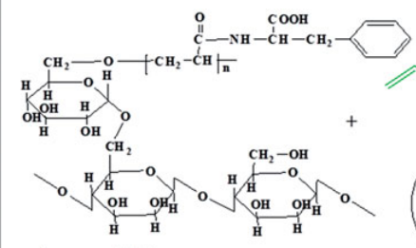

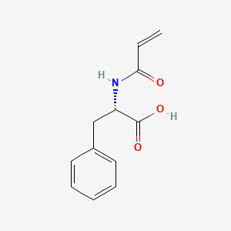

N-Acryloyl-L phenylalanine

As per above structures we identify that the CH2OH group is reactive towards free radical polymerization.

Another structure is to be shown below which is a modified version of guar gum and it is hydrophobic in nature.

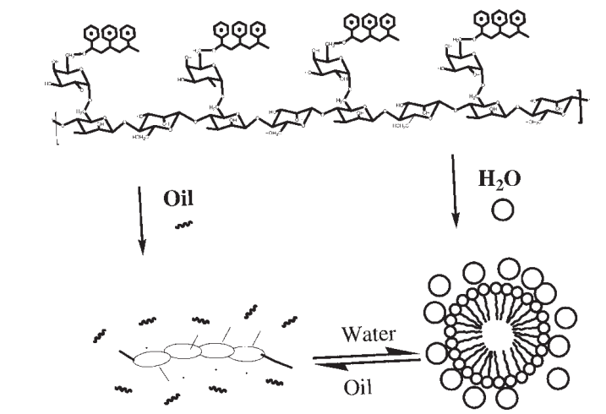

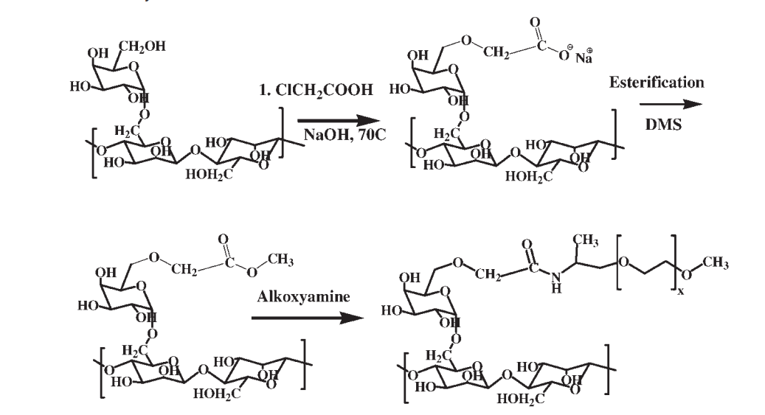

polyalkoxyalkyleneamide grafts to guar gum

As we can see from above figures that by adding long chain hydrocarbon on guar gum, its hydrophilic behaviour reduces and it shows hydrophobic nature. In the same manner above structure’s one side has long hydrocarbon chain whereas the other side where lot of OH group exists, shows hydrophilic behaviour. Because of this it form micelles like orientation when it contacts with oil and water.

Reaction steps: first we do carboxymethylation. For it react guar gum with sodium acetic acid in the presence of NaOH.

In second step perform esterification of above product by dimethyl sulphate.

In third step react with alkoxyamine and by completing all these steps we will get desirable product.

Effect on viscosity

Because of adding a long hydrocarbon chain viscosity decrease.

Guar gum derivatives

carboxymethyl guar gum

Hydroxymethyl guar gum .

Hydroxypropylethyl guar gum.

O-carboxymethyl- O-hydroxypropyl guar gum (CMHPG) ..

Ammonium hydroxyl propyl trimethyl chloride of guar gum

O-carboyxymethyl-O-2 hydroxy-3-(trimethylammonia propyl) guar gum (CMHTPG)

Acryloyloxy guar gum

Methacryloyl guar gum

Guar gum esters